Subject Name: **Front End Engineering**

Subject Code: **22CS004**

Session: **2022-23 (Group – 17)**

Department: **DCSE**

logo

|  |  |
| --- | --- |
| **Submitted By:**  TARANPREET SINGH : 2210992454  TARANVIR SINGH : 2210992455 TARANVEER SINGH : 2210992456  TARUN (LEADER) : 2210992457 | **Submitted To:**  Ms.Sonam Mittal |

**DECLARATION**

I hereby declare that this is our own work. The references used in this project, survey form is used and will be mentioned in the bio of the project. I, with my team of programmers, Taranpreet Singh, Taranvir Singh, Tarnveer Singh, Tarun have been working on the same and gained a lot of experience throughout the process.

**Sign of Faculty Coordinator**

**ACKNOWLEDGEMENT**

I am glad to present my computer project. This project was given by our respected Faculty Co-ordinator Dr. Sonam Mittal. I am really thankful to her for giving us such a wonderful and interesting topic for project.

It would had been not possible without her help. I would like to thank everybody who were involved in this project. This would not be possible without their help.

**INTRODUCTION**

The aim of this project is to provide a comprehensive understanding of HTML and its application in the development of a survey form. We have incorporated various HTML elements, attributes, and CSS styling to create an interactive and visually appealing form. Another purpose is to build understanding on the implementation of HTML, CSS and to showcase our potential as a team.

Our goal is to provide a comprehensive understanding of HTML and its practical application in the development of a survey form. We hope this project will serve as a valuable resource for anyone interested in HTML development and inspire them to create their own functional survey forms.

**PROBLEM STATEMENT**

The problem we aim to solve with our survey form project is the need for a user-friendly and effective tool for collecting accurate and relevant information from a specific target audience. Traditional paper-based surveys can be time-consuming and costly, and online surveys can often be confusing and frustrating for respondents.

Our survey form project seeks to address these issues by providing a functional and interactive online survey form that is easy to use and navigate for respondents. We aim to create a form that not only collects accurate and relevant data but also provides a positive user experience for respondents.

**KEY FEATURES**

**HTML:**

HTML stands for Hyper Text Markup Language. It is used to design web pages. Hypertext defines the link between web pages. Most markup languages are human readable and html uses tags.

**CSS:**

Cascading Style Sheets, fondly referred to as CSS, is a simply designed language intended to simplify the process of making web pages presentable. CSS allows you to apply styles to web pages. More importantly, CSS enables you to do this independent of the HTML that makes up each web page. It describes how a webpage should look.

**WORKING OF THE PROJECT**

1. The very first page of the program includes filling up of personal details such as name, email, roll no. etc.

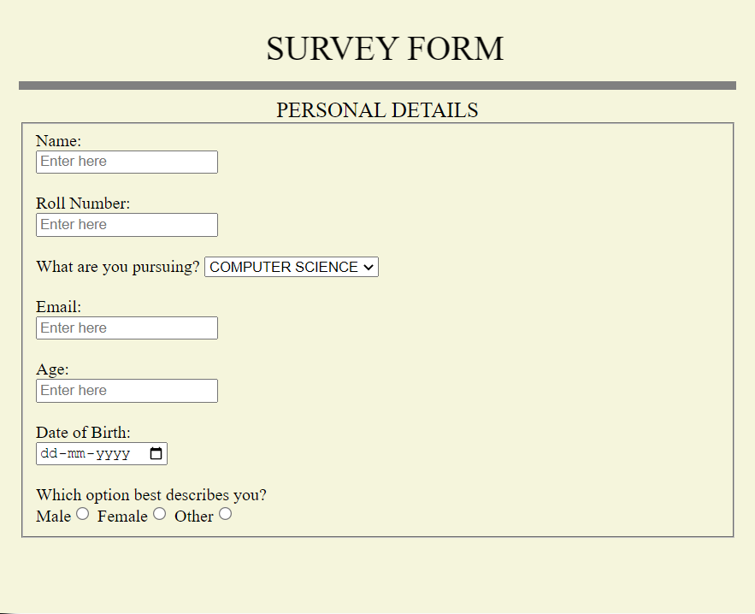

2. The second page includes the questions asked in the survey.

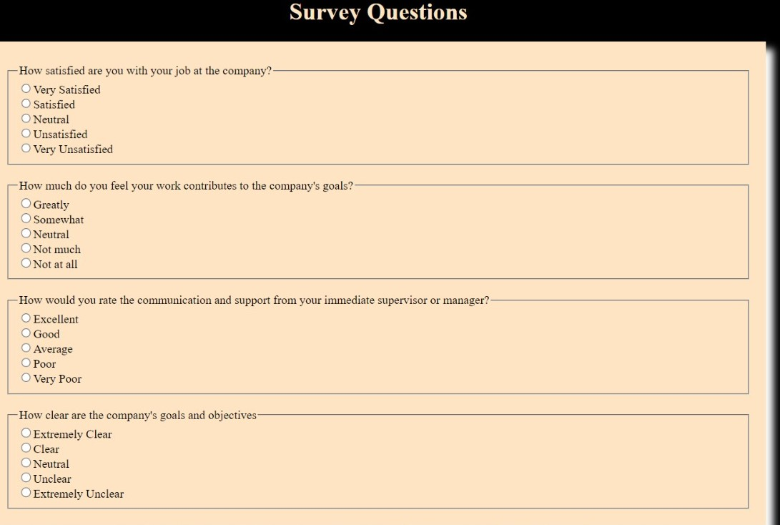

3. The last page is for feedback.

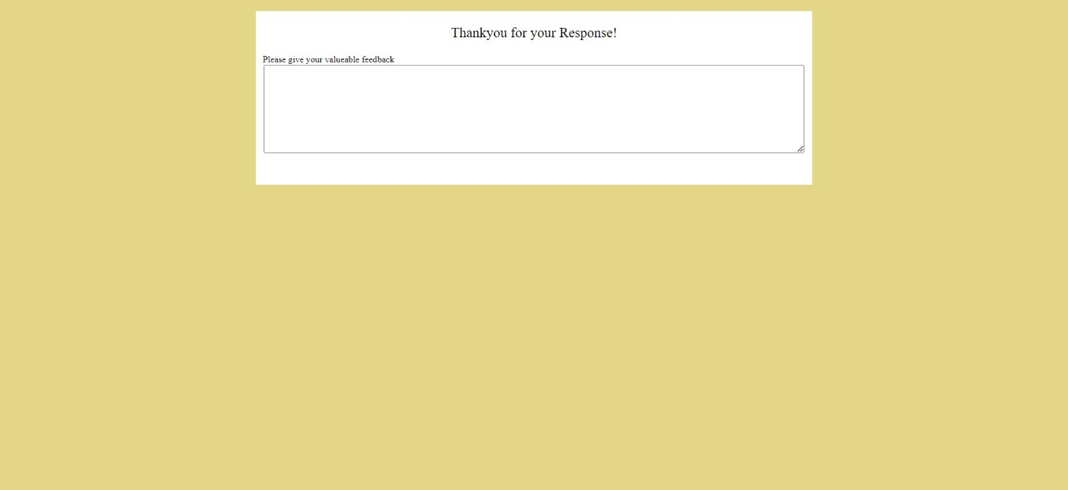

**KEY FEATURES**

1. User-friendly interface: Our survey form will have a simple and intuitive interface that is easy to use and navigate for respondents.

2. Clear and concise questions: The survey questions will be well-written, clear, and concise, making it easy for respondents to understand and answer them.

3. Multiple question types: Our survey form will incorporate different question types, such as multiple-choice, rating scales, and open-ended questions, to collect a wide range of data from responde

**CONCLUSION**

The HTML survey form project has provided us with an opportunity to explore and showcase our understanding and application of HTML in developing a functional and user-friendly survey form. Through the project, we have identified the key features required for a survey form to collect accurate and relevant data from a specific target audience.

Our survey form incorporates various HTML elements and attributes, as well as CSS styling, to create a visually appealing and interactive form that meets the needs of our target audience. Additionally, our form includes validation and error handling, ensuring that respondents fill out the form correctly and preventing errors and mistakes.